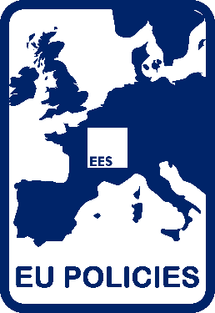

quality of life as an evaluation criterion

10-11/FEB 2021

ees THematic working group 7 on eu policies

czech evaluation Society

ministry of regional development of the czech republic

Programme
February 10, 2021 (15:00-17:25 CET)
Moderators: Jana Drlíková / Oto Potluka
15:00 – 15:10 | Introduction  Oto Potluka
15:10 – 15:40 | Beyond equity and equality: Justice as an evaluation criteria for evaluating technology for good projects to achieve quality of life  Valentine J Gandhi (The Development CAFÉ), and Michael Quinn Patton (Blue Marble Evaluation)
15:40 – 16:10 | Evolution of the meanings and importance of the “quality of life” concept in the cohesion policy evaluation in Poland 2004-2020  Tomasz Kupiec (University of Warsaw)
16:10 – 16:25 | Coffee Break
16:25 – 16:55 | Quality of life in EU policies and their evaluations: Evaluating financial assistance in crisis  Dusan Kovacevic, Kari Korhonen, and Olga Francova (The European Stability Mechanism)
16:55 – 17:25 | Mental health as an evaluation criterion in the social actions  Radosław Rogoza, Monika Bartosiewicz-Niziołek, and Jan Cieciuch (Cardinal Stefan Wyszyński University in Warsaw)

February 11, 2021 (9:00-11:30 CET)
Moderators: Michal Horáček / Roman Matoušek
09:00 – 09:30 | Digital resilience evaluation framework to withstand against COVID-19 or pandemic situation to achieve the Sustainable Development Goals  Mahsin Hammuda (UNDP)
09:30 – 10:00 | Using well-being as an evaluation criterion: lessons from IBEST, a French experience  Hélène Clot, Thomas Delahais, and Fiona Ottaviani (Quadrant Conseil)
10:00 – 10:15 | Coffee Break
10:15 – 10:45 | Evaluating quality of life of older persons in the INTERREG project “Age-friendly Region” in the Austro-Hungarian border region  Rahel Kahlert and Christian Boehler (European Centre for Social Welfare Policy and Research)
10:45 – 11:15 | How infrastructures contribute to improve quality of life and how to evaluate this contribution  Chiara Pancotti, Pedralli Matteo, Pellegrin Julie, and Vignetti Silvia (CSIL)
11:15 – 11:30 | Concluding remarks and further development  Oto Potluka

The workshop will be held on-line. If you want to attend, please, contact Oto Potluka (oto.potluka@unibas.ch).
Please, visit us on the website https://europeanevaluation.org/twg7-eu-policies/ if you are interested in getting more information about the Thematic Working Group 7 of the European Evaluation Society.

