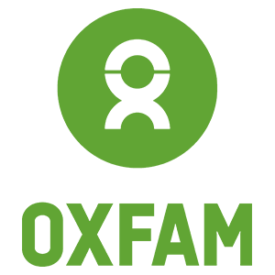
Request for Proposals: Developing a methodology to learn about and measure connectivity

- Background and rationale of the consultancy
There has been an attempt to methodologically and thoroughly measure connectivity in a previous Disaster Risk Reduction and Resilience (DRR/R) regional program in Central America (Guatemala, Nicaragua and El Salvador) named ATECA (Early Action in Central America) between 2021 and 2020. What was developed then is a Community Connectivity Index and its methodology at baseline and end line stage of the regional program.
It was then understood that connectivity is the capacity of individuals, communities, territories, peoples or countries to communicate with other relevant actors in such a way as to transfer experiences, knowledge and exchange of goods or services, using different means of communication, whether material or immaterial.
The index measured connectivity at community level and was comprised of 3 dimensions: level of connection with actors of interest, access to technology and means of communication, information flow. Each dimension had their respective quantitative indicators to average all the data into indexes for each dimension, and to obtain an overall index.
This first experience of defining and measuring connectivity in communities of Central America brought a lot of lessons and raised a lot of questions on the meaning of an index and the validity of the methodology and approaches used throughout the entire process.
In this initiative, we would like to integrate a broader dimension to the concept of connectivity, as a collaborative, multi-actor approach, a system thinking about the problems that people face where the intersectionality and interconnectedness of power, social and economic dimensions deeply rooted and encountered at multiple levels. Connectivity as a means not an end and powerful means that requires solidarity, collective efforts from multiple actors at all levels to increase the resilience of the most vulnerable.
To date and after consulting with staff from Oxfam and partner organizations’ staff working on Monitoring and Evaluation and Program Implementation in Central America, we would like to build on this first experience to learn more and better about connectivity in the particular contexts of the Central American DRR/R program, ATECA 2 currently being implemented in Guatemala and El Salvador, to develop the most adequate participatory methodology and methods to measure connectivity. As a result, it is expected to develop a methodology and tools that is replicable by adjusting it depending on the contexts that Oxfam work on and with, either social, political, economic, cultural, programmatic, etc.
Purpose and objectives of the evaluation
The purpose of this consultancy is to develop and validate a methodological process and its tools to appropriately measure connectivity based on a local understanding of connectivity and what is at stakes in the different contexts where the project is implemented so that measuring connectivity is replicable for other Oxfam’s thematic areas that Oxfam and partners work in.
The specific objectives are:
- Through a collaborative approach with local actors, conduct local consultations with the targets groups which could be benefit from measuring their level of connectivity in El Salvador and in Guatemala to learn about what connectivity means in those specific contexts
- Develop adequate and participatory data collection methods/tools that will allow to measure connectivity in those contexts
- Present the results of the connectivity measurement to the targeted audience through reflection workshops in order to validate, allow change agents to come up with their own recommendations
- Systematize, develop and present methodological guidelines and tools on how to conduct and adapt the data collection methods/tools for measuring connectivity

- Key Learning Questions on Connectivity
Diagram on what we want and need to learn about connectivity in a local context:
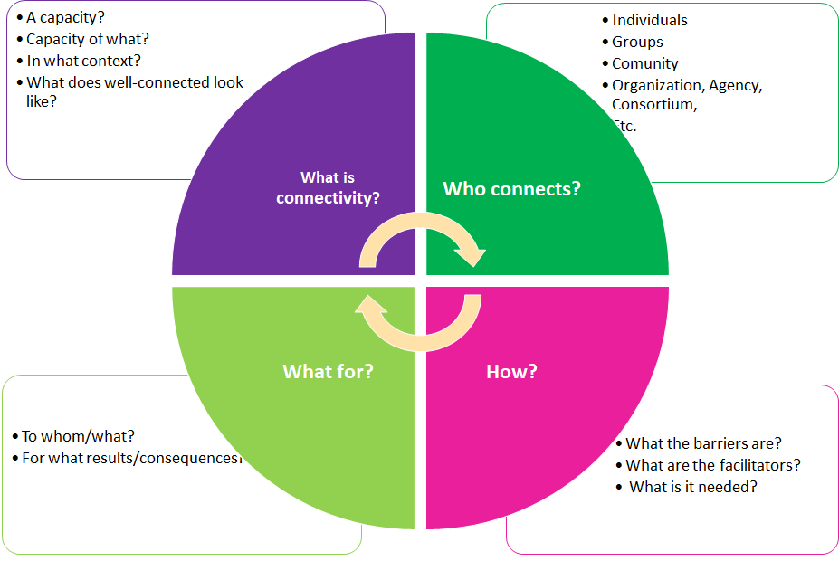
- What does connectivity mean: What aspects best describe the connectivity capacity of a community from the perspective of its members? From the community's perspective, what is the purpose of improving its connectivity.
- Whose connectivity: We measure the connectivity of who and why, of an individual, group, a community, organization, agency, or a consortium?
- What are the outcomes of this connectivity: From the perspective of the community, what is the purpose of improving its connectivity and what effects does improving it generate?
- How do the connections occur: What are the barriers, drivers/enablers, and resources needed to improve connectivity in the communities' view?
- Scope of the consultancy and approach and methods, establishing the basic methodological requirements
This consultancy is limited to the context of the ATECA program implemented in Central America: one department of El Salvador (Morazán) and two departments of Guatemala (Chiquimula and Baja Verapaz). This program started in October 2020 and will end in December 2022. ATECA’s purpose is to ensure that communities in Central America’s Dry Corridor region have better capacities to prepare for and to co-lead response and recovery efforts to small-scale emergencies, especially those caused by ”low-attention” natural hazards, and thus reducing their vulnerability to disasters.
The scope already identified by the partner organizations working in the areas where the project is implemented
The partner organizations implementing the ATECA project in El Salvador and Guatemala have identified at which level and which target groups they are interested in to measure their connectivity. This list is susceptible to change or prioritization:
Guatemala | El Salvador
Community leaders  Members of COLRED (Local Disaster Committees)  Youth  Producers  *Inter- and intra-group relations | Women participants of the School of Leadership  Savings group women  Youth  Members of the Community Civil Protection Commissions  Mayors  General Directorate (at municipal or departmental level) for Civil Protection  National Center for Agricultural and Livestock Technology  Local Institutions for Violenca Reporting

Some methodological expectations:
- Anti-colonial: through a co-learning process and where there is an understanding of what connectivity means for a specific group in a specific context
- Participatory: by using participatory tools and methods to collect data and present the information analyzed in a visual and accessible way in the local language, this principle also refers to power-sharing approach of decision making throughout this consultancy process
- Inclusiveness: by being sensitive to the differential experiences that people and groups may experience, their different ways of communication and levels of understanding information, and by using the most adequate methods that will allow everyone to feel safe to participate and to have their voice heard in this process.
- Reflexivity: by examining the consulting team and other parties' own beliefs, judgments and practices during the research process and how these can influence the process and the results.
- On-site or remote data collection: In this COVID-19 pandemic context, it has to be evaluated at what times and in what way information can be collected from the target respondents depending on the restrictions of the authorities and following Oxfam's protocols.

- Expectations and Support to Consulting Team
The expected competencies and skills in the evaluation team are:
- Proficiency in social research or other similar certified courses relevant to this consultancy.
- Have a minimum of 7 years of in person or remote data collection and analysis of qualitative data, and community development, community mobilization and other relevant fields
- Have very solid knowledge of and experience using a participatory and inclusive approached in data collection, analysis and presentation process, especially in networks/stakeholders analysis and mapping
- Have working experience in the regions or similar countries where the program has been implemented
- Have a good understanding and demonstrating application of gender sensitive and/or feminist standards and principles in evaluation to integrate into data collection, analysis and reports or documents
- Good verbal and written communication and interpersonal skills to accurately and concisely convey information to different audiences, and to liaise with in-country teams, local implementing partners, local stakeholders and community members in a respectful and culturally appropriate manner.
- Experience in effectively presenting findings in an accessible, inclusive and culturally appropriate manner, create and moderate spaces for reflection with local actors
- Have Spanish (requirements) language skills to communicate with Oxfam and partners staff and local actors in targets locations of the projects
- Must comply with Oxfam’s Safeguarding Principles and Code of Conduct

The Humanitarian MEAL Advisor will be the focal point of contact and will be supporting the Consulting Team through this contract, ensuring that:
- all documents and information required for this consultancy is handed to them,
- their enquiries or questions are responded in timely manner,
- they are introduced to country teams and they have the logistical support needed for their in-country trips.

- Calendar of activities, deliverables and budget

Activities | Deliverables | Estimated Working Days
Desktop Review of Project Document and Literature Review of Connectivity work + Coordinate and Prepare logistics for field work | Short Inception Report with clear road map, timeline and methodology, interview/consultation guide | 4 days
Conduct rounds of consultations (in person and online) with local actors in El Salvador and Guatemala | Update the Inception Report with what was learned from the field consultations | 4 days per country
Develop data collection methods and approach to measure and collect data to measure connectivity of specific (TBD) groups | Data collection methods | 6 days per country
Analyze the data collected | If adjustments are necessary, update the initial report on the data analysis method(s). | 5 days
Present the analysis through workshop and group discussions with the specific groups via visualization tools and representation of the information to trigger reflection | Half-day workshop conducted with a well-structured program for presentation of findings, group reflection and recommendations | 2 days per country
Draft a succinct report on the results after workshop conducted and methodological guidelines to replicate the approach | Draft report and guidelines | 5 days
Submit the final versions of the succinct report and guidelines | Final versions of report and guideline document and tools | 1 day
Present the methodology and process to Oxfam and implementing partners | PPT Presentation with guideline document and tools | 1 day
TOTAL |  | 28 - 40 days

Financial Proposal: The preliminary proposal/expression of interest should present everything including consulting fees, all costs associated with performing the consultancy and a contingency for incidentals. Proposals will be compared against each other with respect to the feasibility, rigor and efficiency of the proposed methods within this budget limit.
Note: In this consultancy, Oxfam will not provide physical space, computer equipment or transportation to the consulting team to carry out the consultancy. However, support will be provided with information and some coordination and preparation support for the consultations, data collection and feedback to key stakeholders, either face-to-face or online.
- Reporting requirements
Reporting to Oxfam and Partners
The following suggested reporting restructure should be confirmed jointly with the consulting team, partners and Oxfam:
- Aim and purpose of the document
- How to use the document
- Process to measure connectivity
  - What to adapt
  - Dos and don’ts
  - Challenges and mitigation measures
  - Basket of participatory tools
- References and Other participatory tools
Reporting to Project Participants
The reporting requirements should take the following into consideration but are not only limited to those and more aspects could be included depending on the need and context:
- Using the same participatory tools and approaches when conducting consultations and when measuring connectivity to present information in an accessible manner to participants
- May use interpreters or translate the tools and presentation materials to the local language
- Be inclusive of all members that should have access to the information, and leave space for participants to speak and interact with the information shared with them
- Process the discussions and feedback from participants in order to integrate those in the methodological guidelines
- Use dynamic methods and activities to build rapport and create a safe space for the participants
- Etc.
Disclosure: The consultation team must abide by Oxfam’s Responsible Program Data Policy. It is prohibited to disclose all data and information provided by communities, partners organizations and Oxfam. The products produced shall be the property of the partner organizations and Oxfam, and may not be disclosed, reproduced, marketed or shared by any means, without the prior written permission of the parties concerned.
Informed consent: Any information requested from any informants must be supported by a document stating that the information was voluntary and that they approve being included in any publication.
- Process of the selection of the evaluation team and expectation for evaluation proposal
Oxfam invites bids from individuals and groups of individuals with the experience and skills described above. Please send the following to Marion Cabanes at marion.cabanes@oxfam.org by 17 September 2021:
- A brief 2 to 3-page expression of interest with a description of the proposed methodological approach, description of deliverables, a proposed budget, a brief summary of qualifications, and attached sample of previous work.
- A CV detailing relevant skills and experience of no more than 4 pages, including contactable referees (if a group, a CV should be submitted for each member of the evaluation team)
Phone interviews with eligible candidates will be held the week of the 20 September 2021. Final selection will be made the week of 30 September 2021.
Selection criteria to be applied:
•Quality of the methodological proposal: aspects that will help us to assess their suitability for that which is proposed in the RFP, quality of the proposal, feasibility, etc.
•Profile and competencies of the evaluation team: knowledge, experience, composition and other necessary competencies.
•Suitability of the financial proposal: for the activities laid out in the methodology, within the financial possibilities of the project, etc.
Selection criteria that we will apply:
Criteria | Description | Weight
Quality of the methodological proposal | Aspects that help us to assess its appropriateness to what is looked for in the RFP, quality of the proposal, feasibility, etc. | 40%
Profile and competencies of the evaluation team | Knowledge, experience, composition and other required competencies | 40%
Appropriateness of the financial proposal | Appropriateness to the planned activities in the RFP, and to produce with quality the expected products. | 20%

