NRF – midterm review technical proposal

Submitted by: Name(s) or Organisation
  - Month Year

About the Nutrition Research Facility
The Knowledge and Research for Nutrition project of the European Commission (2020-2024) aims to provide improved knowledge and evidence for policy and programme design, management and monitoring & evaluation in order to reach better nutrition outcomes.
The project is implemented by Agrinatura - the European Alliance on Agricultural Knowledge for Development – which has established a Nutrition Research Facility, pooling expertise from European academia and having the ability to mobilise internationally renowned scientific networks and research organisations from partner countries.
The Nutrition Research Facility provides expert advice to the European Commission and to the European Union (EU) Member States and Partner Countries.
Contact: nrf@agrinatura-eu.eu

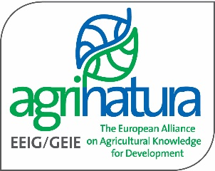

Disclaimer
This publication was produced with the financial support of the European Commission. Its contents are the sole responsibility of AGRINATURA and do not necessarily reflect the views of the European Union.

List of acronyms
Acronym | Description

Contents
1 Introduction 3
2 Methodology 3
3 Team composition and tasks 3
4 References to past similar experiences 3
References a
List of Annexes a

Introduction
[Understanding of ToR and the aim of the services to be provided; declaration regarding conflict of interest]

Methodology
[Overall methodological approach, quality control approach, appropriate mix of tools and estimate of difficulties and challenges]
Table 1. Table template

Team composition and tasks
[Qualification of tenderer; backstopping; organisation of tasks]

References to past similar experiences
[links to previous similar experiences]

References

List of Annexes
[provide a list of annexes; and respective annexes]
No | Title
1
2
3

